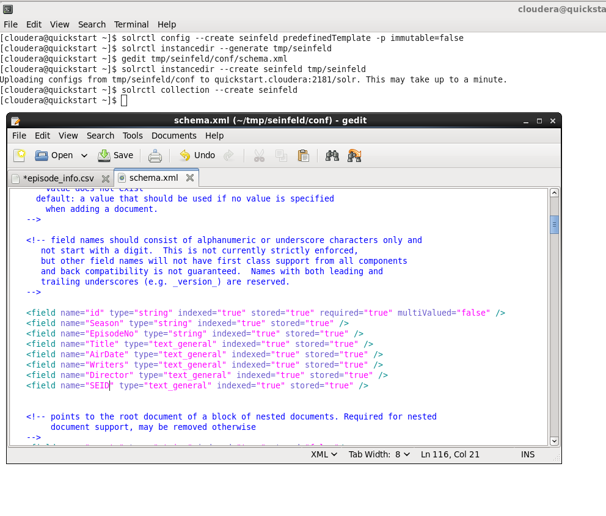

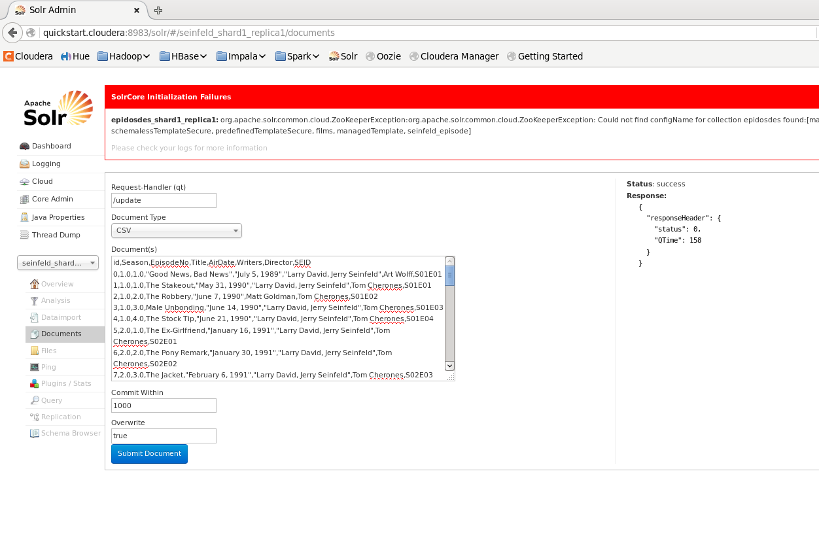

[cloudera@quickstart ~]$ solrctl config --create seinfeld predefinedTemplate -p immutable=false

[cloudera@quickstart ~]$ solrctl instancedir --generate tmp/seinfeld

[cloudera@quickstart ~]$ gedit tmp/seinfeld/conf/schema.xml

[cloudera@quickstart ~]$ solrctl instancedir --create seinfeld tmp/seinfeld

Uploading configs from tmp/seinfeld/conf to quickstart.cloudera:2181/solr. This may take up to a minute.

[cloudera@quickstart ~]$ solrctl collection --create Seinfeld

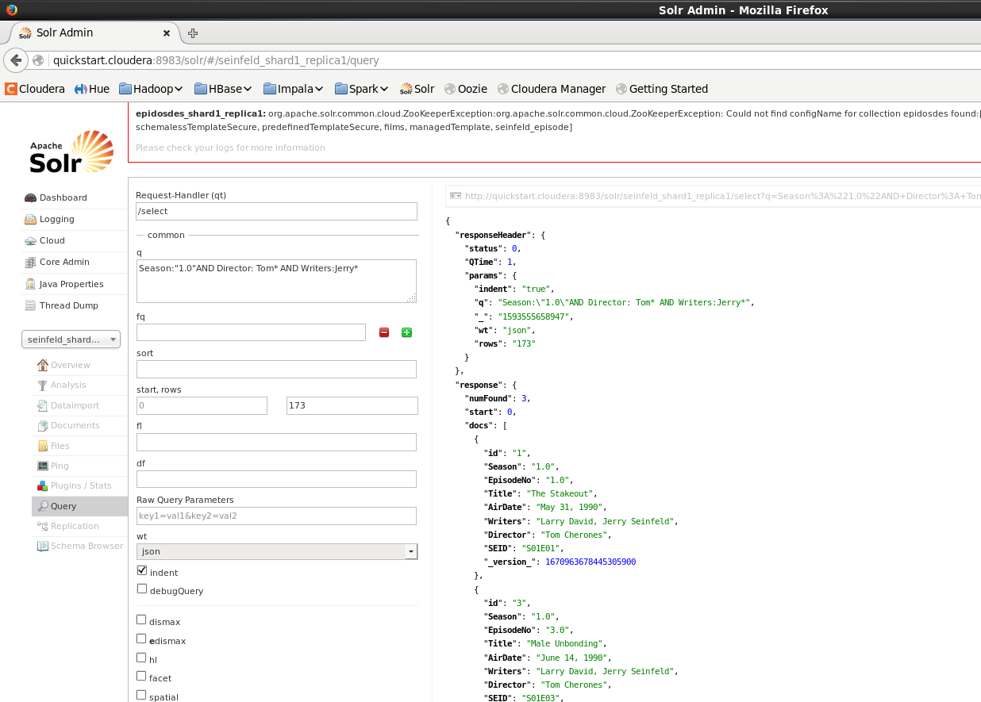

Season one episodes directed by Tom with Jerry listed as a writer

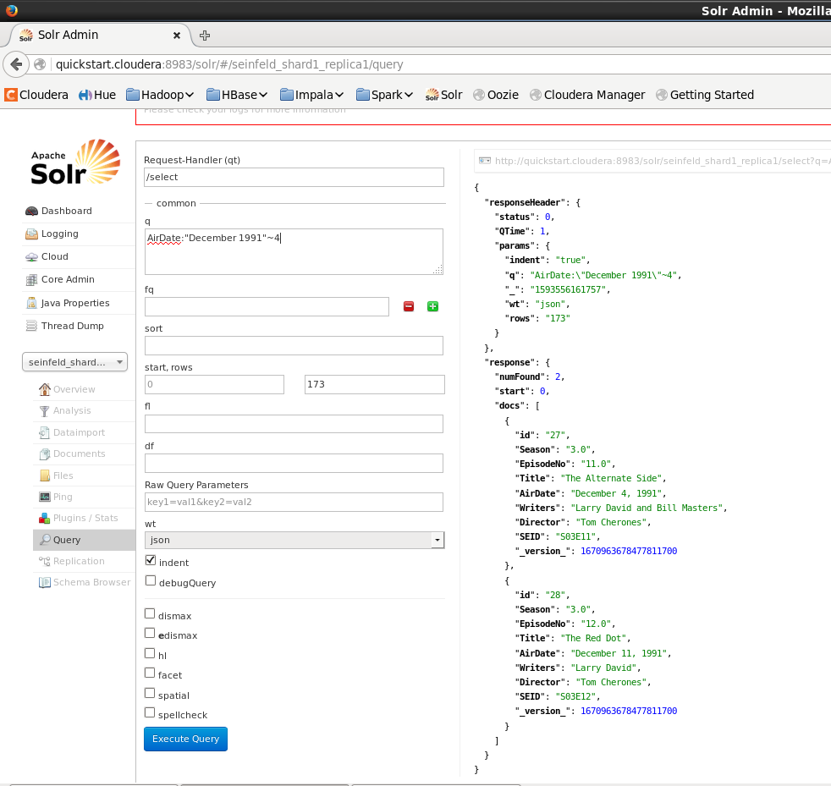

Air date of December 1991

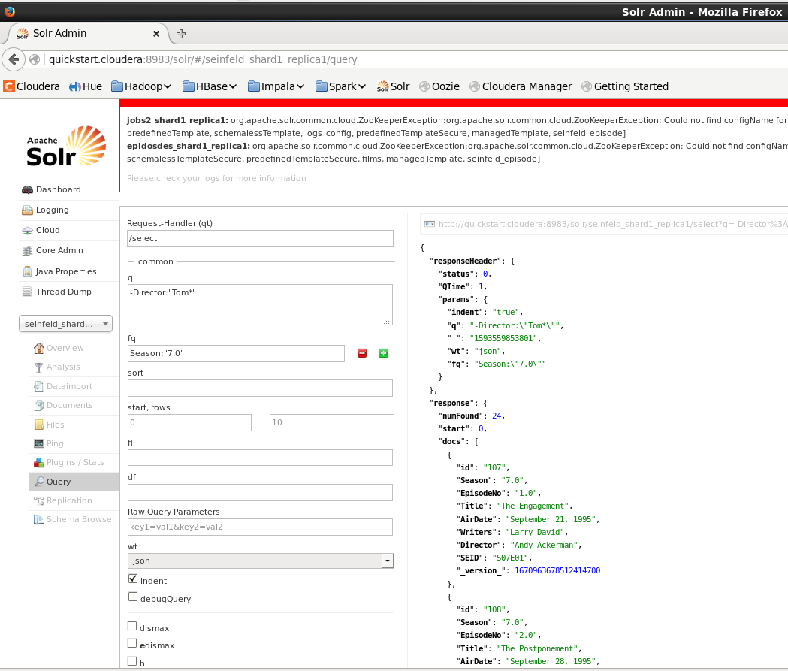

Episodes from season 7 that were not directed by Tom\*

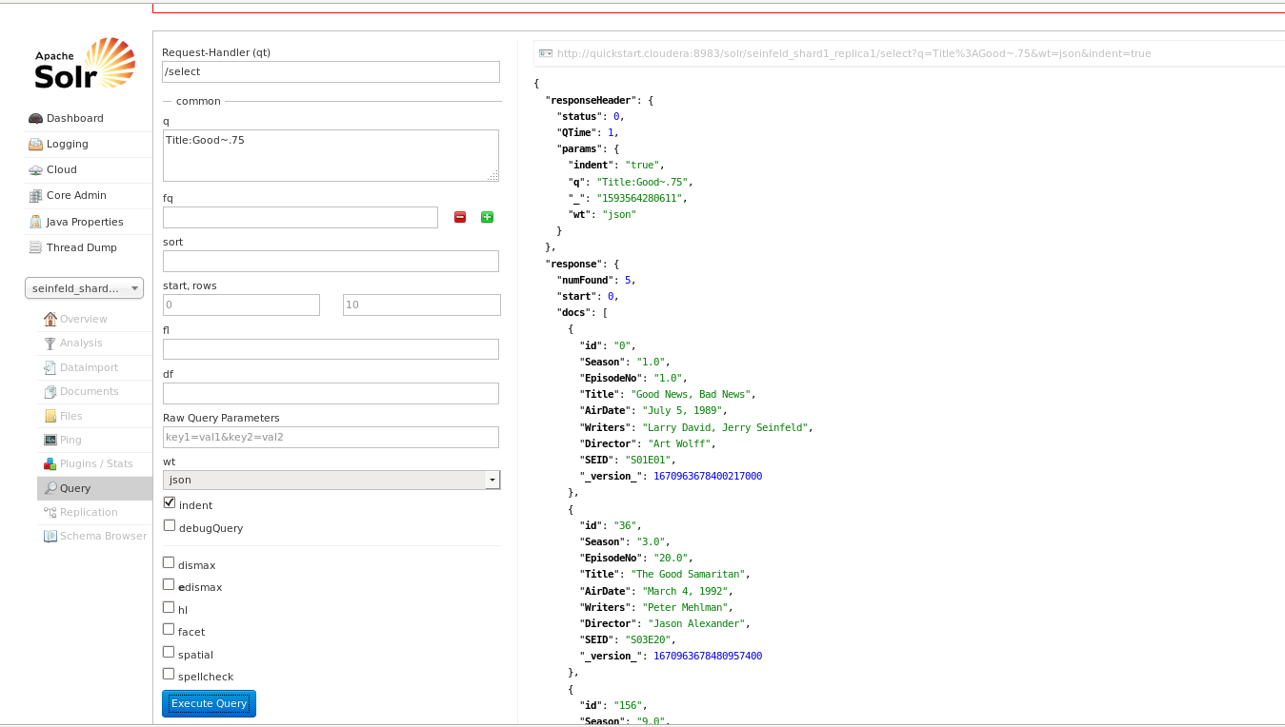

Fuzzy search title good

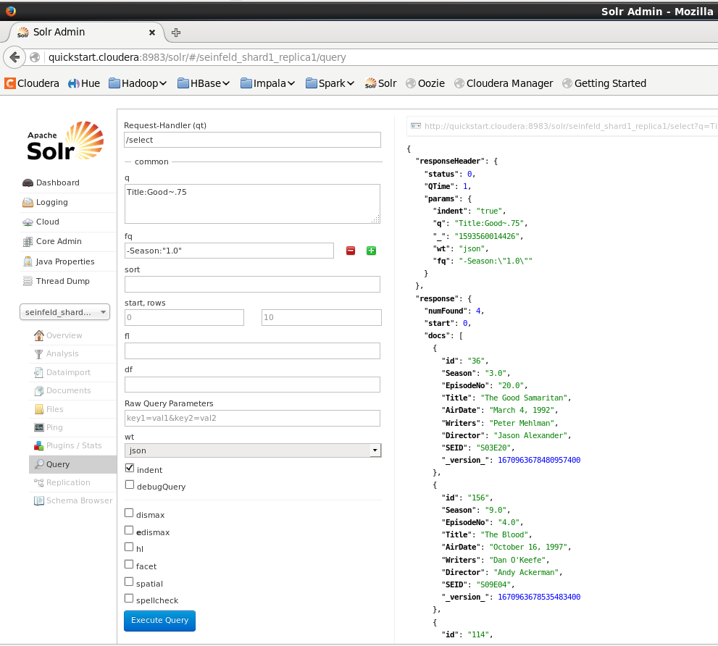

Fuzzy Logic Search not containing season 1

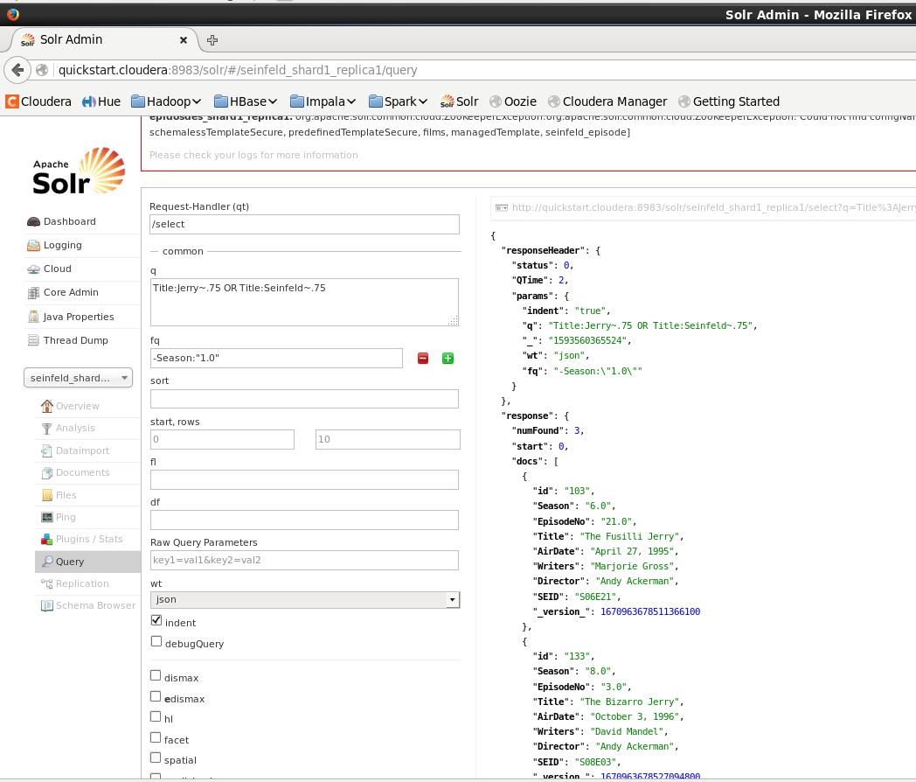

Fuzzy Logic on 75% of Jerry or Seinfeld

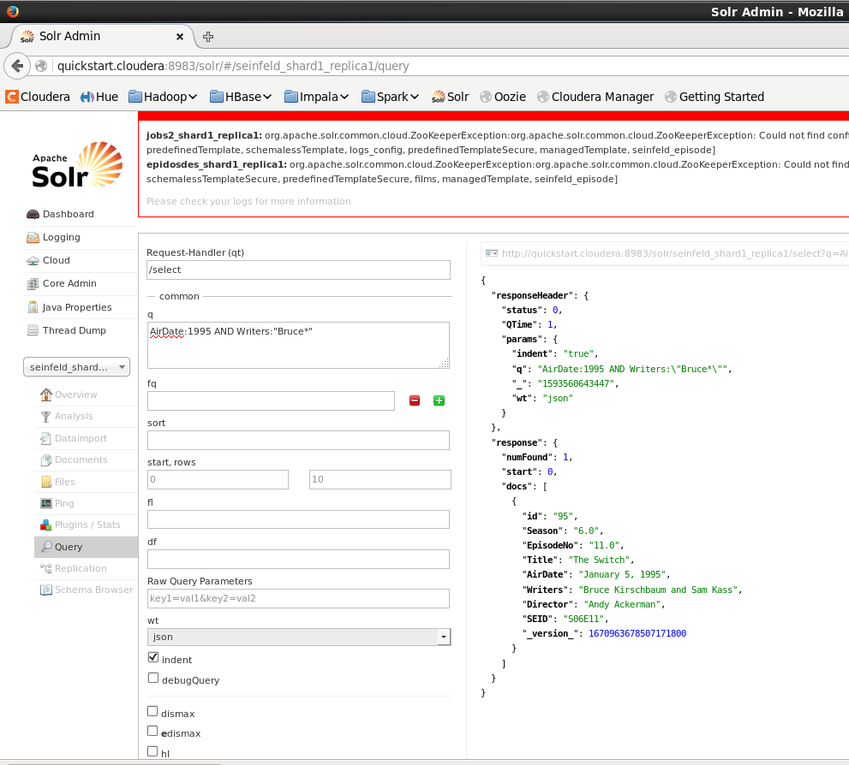

AirDate 1995 and Writer is Bruce.

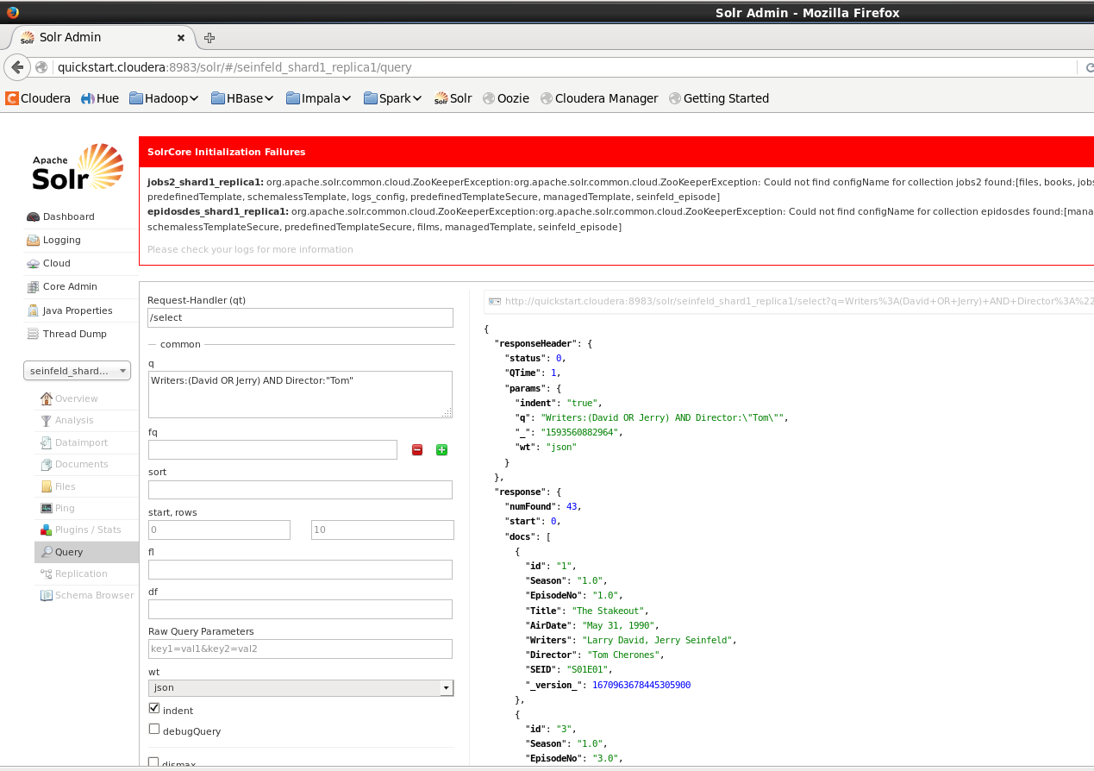

Writer is David or Jerry and director is Tom.

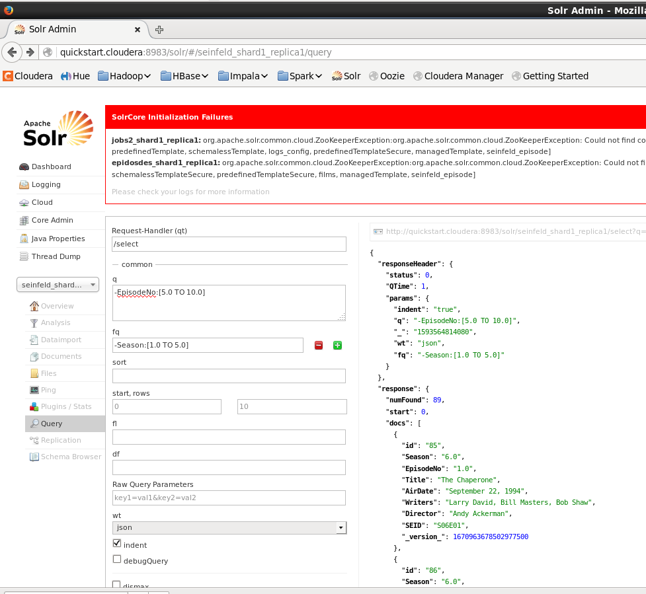

Episode is not between 5 and 10 and season is not between 1 and 5.

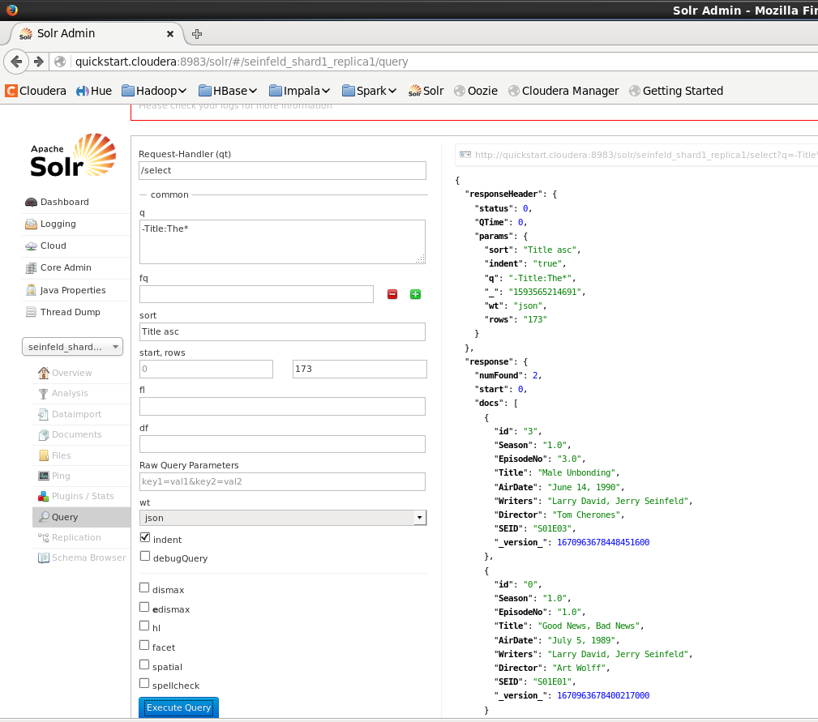

Title does not include the and in ascending order of title